Maps & Directions

We are excited to welcome you to NAOCE！

Our Location
NAOCE is located in Ruth Mulan Chu Chao Building on SJTU Minhang Campus, which is on No. 800, Dongchuan Road, Minhang District, Shanghai.
View SJTU Campus Map

View Ruth Mulan Chu Chao Building
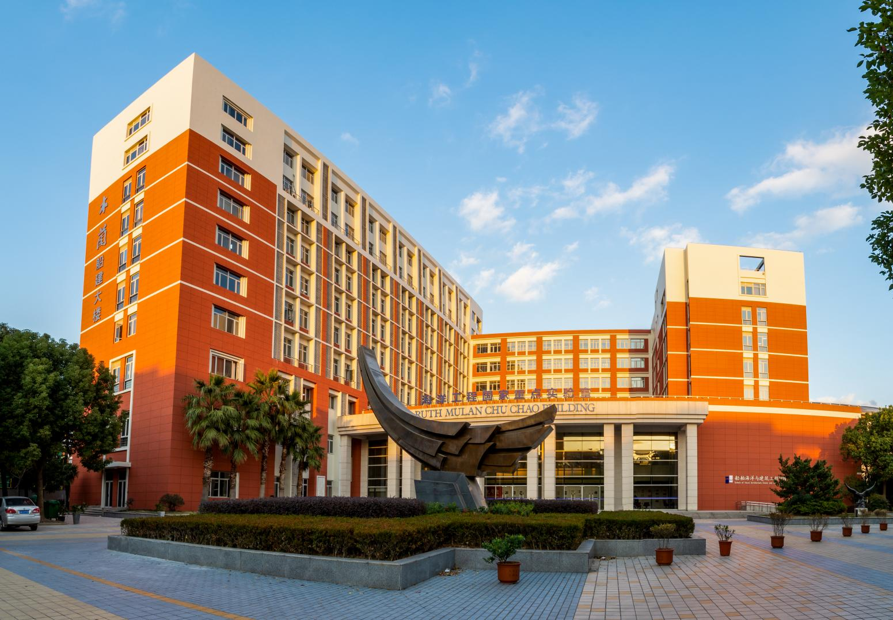

How to get to SJTU Minhang Campus

By public transportation

A. Zizhu Hi-tech Park, Line 15 (Shanghai Metro System)
Please get off at Zizhu Hi-tech Park Station, go out through Exit 7, then walk into the Campus at No. 3 East Gate (No. 5200, South Lianhua Road), and arrive at Ruth Mulan Chu Chao Building.

B. SJTU Minhang campus is also close to Dongchuan Road Station, Line 5.
Please get off at Dongchuan Road Station, go out through Exit 4, then take bus Jiangchuan No.3 or Jiangchuan No. 7 to the main gate of SJTU on No.800, Dongchuan Road, then take Minhang Campus Bus to Ruth Mulan Chu Chao Building.

By driving or taxi
Please be aware the recommendation is only for your reference, there is more than one way to get to SJTU Minhang Campus, please take your way according to actual situation.

From Pudong International Airport
- Depart from the airport
- Shenjia Lake Highway (42.7km)
- Hujin Highway (640m)
- Jianchuan Road(1.5 km)
- Arrive at SJTU Minhang Campus
Driving: about 49 km/46 minutes’
Taxi: about 210 RMB

From Hongqiao International Airport or Hongqiao Railway

Station
- Depart from the airport or railway station
- Jiamin Overpass (17.4km)
- Shenjia Lake Highway (2km)
- Jianchuan Road (1km)
- Arrive at SJTU Minhang Campus
Driving: about 27km/40 minutes
Taxi: about 100 RMB

From Shanghai Railway Station
- Depart from the railway station
- Inner Ring Overpass(11km) &
- Humin Overpass (7.5 km)
- Xinzhuang Overpass (2.2km) & Hujin Highway (9.2km)
- Jianchuan Road (1km)
- Arrive in SJTU
Driving: about 35 km/1 hour
Taxi: about 150RMB

From Shanghai South Railway Station
- Depart from the railway station
- Humin Overpass (4km) & Xinzhuang Overpass (2.2km)
- Hujin Highway (9.2km)
- Jianchuan Road (1km)
- Arrive at SJTU Minhang Campus
Driving: 20km/1 hour
Taxi: about 90 RMB

From Xuhui Campus
- Humin Road(1km)
- North Caoxi Road (900m) & Humin Overpass (7.9km)
- Xizhuang Overpass (2.2km) & Hujin Overpass (9.2km)
- Jianchuan Road
- Arrive at SJTU Minhang Campus
Driving: about 26km/1 hour
Taxi: about 100 RMB

How to get to Ruth Mulan Chu Chao Building on Minhang Campus

By Minhang campus bus
You may take the Minhang Campus Bus and get off at “School of Naval Architecture Ocean & Civil Engineering” stop.

SJTU Xuhui←→Minhang campus shuttle bus
Shuttle School Bus
Price: 6 RMB / person / time

Lodging Options
- Academic Exchanges Center on SJTU Minhang Campus
- Address: No. 800, Dongchuan Road, Minhang, Tel: 021-54740800
- All Seasons Hotel(SJTU Area)
- Address: No. 445, Humin Road, Minhang, Tel: 021-60296355
- Huhua International Hotel (Wujing Area)
- Address: No. 368, Jianchuan Road, Minhang, Tel: 021-64508999
- Courtyard by Marriott Shanghai Minhang
- Address: Building 3, No. 588, Zixing Road, Minhang, Tel: 021-32029000

Mailing address
School of Naval Architecture Ocean & Civil Engineering Ruth Mulan Chu Chao Building, No. 800 Dongchuan Road, Minhang District, Shanghai, China. Postcode: 200240

